Mobility Services Department Year-to-Date First Quarter 2020 Report
CONTENTS

ADA Paratransit Certification 2
ADA Paratransit Eligible Customers 3
ADA Paratransit Applications Received 4
Customer Programs 14
Ride Free and Reduced Fare Permits 14
Walk-In and Telephone Customer Service 16
Travel Information Center (TIC) 18
Travel Information Phone Calls 18
Mobility Management 22
Travel Training 22
Group Transit Orientation Presentations & Community Outreach 25

ADA Paratransit Certification

The ADA Paratransit Certification Program determines eligibility for the ADA Paratransit service operated by Pace in the RTA region. ADA Paratransit is an advance reservation, origin-to-destination public transportation service for individuals whose disabilities prevent them from using fixed route service for some or all their travel. Eligibility determinations are made in accordance with the federal Americans with Disabilities Act and U.S. Department of Transportation ADA regulations, following an in-person interview and functional assessment protocol. All completed applications must have a certification decision made within 21 calendar days of the submission date, or presumptive eligibility must be given until the certification decision can be made.
The attached figures provide ADA Paratransit Certification quarterly application data for the first quarter of 2019 through the first quarter of 2020 as well as annual year-to-date (YTD) data for 2016 through 2020. The data includes completed applications received as well as the distribution of new applications, in-person recertification applications, and mail-in recertification applications. Also included are the year-end totals of eligible customers for 2016 through 2020 and the year-to-date total for 2020. In addition, data is provided for the same quarterly and annual time-periods regarding call volumes on the Mobility Services Helpline and its primary menu options.

ADA Paratransit Eligible Customers
As of December 31, 2018, there was a total of 66,994 eligible ADA paratransit customers, reflecting a 3.5% increase in 2018 compared to 2017. As of March 31, 2020, there were 64,647 eligible ADA Paratransit customers, which represented a 1.9% increase from the first quarter of 2020 over year-end 2019 (see Figures 1 and 1a). From year-end 2016 through the first quarter of 2020, the average annual rate of growth in eligible customers was 1%, which is below our projected 6% average annual growth rate for the 5-year period beginning in 2016. It should be noted that the 2019 numbers are negatively impacted due to removing deceased customers from the database during the third quarter of 2019.

ADA Paratransit Applications Received

Quarterly Trends

Application Volume
For the first quarter of 2020, the RTA received a total of 3,648 ADA Paratransit applications, a 15% decrease compared to fourth quarter of 2019.
Figure 2 shows the total number of ADA paratransit applications received during the first quarter of 2020 and in each of the previous four quarters, as well as the volume of each type of application. Figure 2A depicts the percent change in total application volume and of each application type for the same time-period.

Application Distribution
Figure 3 shows the distribution by type of application for the first quarter of 2020 and each of the previous four quarters. New applications are at 48% for the first quarter of 2020, which is slightly lower than the prior quarter. The percent share of in-person recertifications was 31%, which is slightly lower than the prior quarter. Mail-in recertifications accounted for 17% of total applications in the fourth quarter of 2019, which was below the prior four quarters. It will continue to be interesting to see how the distribution of application types may change throughout calendar year 2020.
Figure 4 shows the distribution by type for recertification applications for the first quarter of 2020 and each of the previous four quarters. Mail-in recertifications accounted for 39% of total recertifications in the first quarter of 2020, the highest percentage of the previous four quarters. Since expanding the mail-in recertification process for the second time in 2015, we projected that approximately 40% of recertifications could be completed by mail rather than in-person. It is important to note that the mail-in recertification process has freed up capacity for in-person applications, both new and recertification, at RTA’s Mobility Assessment Centers, and has allowed for a more streamlined recertification process for mail-in applicants. We will continue to monitor these trends.

Annual Trends
Application Volume
Effective on March 16, 2020, the RTA closed both MTM interview/assessment sites due to COVID-19. While ceasing appointments at both interview sites on March 16, 2020, late in the first quarter, there was a significant impact on the first quarter 2020 stats as a result. On a year-to-date (YTD) annual basis, we received a total of 3,648 ADA Paratransit applications through the first quarter of 2020, a 15% decrease over the same time-period in 2019. YTD New applications showed a decrease of 10% in 2020 as compared to 2019. In-person recertifications showed a decrease of 21% in 2020 as compared to 2019. Similarly, YTD mail-in recertifications showed a decrease of 14% in 2020 as compared to 2019. To provide the best service to our customers during the COVID-19 pandemic, the RTA automatically extended all applicants with expiring certifications for six months and provided temporary eligibility to all new applicants for six months as well. We will continue to monitor application volume trends throughout this challenging year.
Figure 5 shows the total number of ADA Paratransit applications received YTD as of the first quarter of 2020 and through the first quarter of each of the previous four years. Also shown in Figure 5 is the volume of each type of application received. Figure 5A depicts the percent change in total application volume and of each application types for the same time-period.

Application Distribution
Figure 6 shows the year-to-date (YTD) distribution by type of application as of YTD of the first quarter of 2020 and for YTD of the first quarter in each of the previous four years. The percent share of new applications was 48%, which was the second highest of the prior four years. In-person recertifications were the second lowest of the five-year time-period and comprised 31% of total applications YTD of the first quarter of 2020. The RTA will closely monitor how the distribution of application types may change throughout calendar year 2020.
Figure 7 shows the year-to-date (YTD) distribution by type of recertification applications as of the first quarter of 2020 and YTD of the first quarter in each of the previous four years. Mail-in recertifications accounted for 39% of total recertifications through the first quarter of 2020, tied for the highest of the five-year time-period. As mentioned previously in this report, since expanding the mail-In criteria in 2015 we projected that approximately 40% of recertifications could be completed by mail rather than in-person. We will continue to monitor this trend on a quarterly as well as an annual basis.

Mail-in recertifications began in 2010 and expanded in 2012 and 2015. Recertification by mail is now an option for customers certified for All Trips eligibility who also meet at least one of the following criteria: (1) 75 years old or older in the year of certification, (2) previously certified for All Trips at least three consecutive times, (3) have advanced dementia or profound intellectual disability and require constant supervision, (4) have a severe physical disability with complex medical needs that require constant monitoring, or (5) have a severe physical disability as defined by diagnosis, prognosis, mobility aid and lack of independent mobility.
Mobility Services Helpline

Quarterly Trends

The Mobility Services Helpline includes a menu of options and serves callers who have a wide array of inquiries about ADA Paratransit Certification and other Customer Programs. The Mobility Services Helpline receives calls regarding application requests, interview appointment scheduling, certification status, ID card questions, as well as general inquiries about ADA Paratransit Certification and other Customer Programs. Due to COVID-19, travel on ADA paratransit decreased significantly and as a result the number of calls into the Mobility Services Helpline also decreased. In the first quarter of 2020, the Helpline received 19,001 total calls, an 11% decrease compared with the fourth quarter of 2019 (see Figures 8 & 8a). A detailed breakdown by call type is outlined in Figures 8 & 8a below.

Figures 9 and 9a reflect YTD volumes of types of calls received through the first quarter of 2020. 6,642 calls (35% of total calls) were regarding status of applications and general inquiries, which was 20% less compared to YTD the first quarter of 2019. 4,239 calls (22%) were requests for in-person Interview appointments, an 11% decrease in the number of calls received in YTD of the first quarter of 2020 compared to YTD of the first quarter of 2019. 6,642 calls (35%) were inquiries from prospective applicants or requests for applications, 20% less compared to YTD of the first quarter of 2019. 1,616 calls (9%) were in the category of other calls, which includes inquiries about ID cards and calls requesting assistance in Spanish, which is a 25% decrease compared to YTD of the first quarter of 2019.

Annual Trends

Customer Programs

The Customer Programs staff is responsible for answering customer calls and providing service to reduced fare and ride free customers at four City of Chicago Department of Family Support Services (DFSS) sites. At these sites, Staff educate older adults and people with disabilities on the steps necessary to obtain the appropriate permit to ride at either half fare or free on CTA, Metra and Pace, and assist customers with replacing lost, stolen or damaged permits.
The Ride Free permit renewal process continues to require that customers first enroll in the State of Illinois Department on Aging (DOA) Benefits Access Program (BAP) before contacting the RTA for a new permit. The RTA continued to use an auto renewal process for those customers in the RTA database who had already completed their BAP application and were approved. The State DOA continues to provide the RTA with the names of BAP enrollees so that the RTA can send renewal Ride Free permits to customers without the customer having to contact the RTA.

Ride Free and Reduced Fare Permits

Quarterly Trends

Figures 10 and 10a reflect the distribution of Ride Free and Reduced Fare Permits for the past five quarters.

As of the end of the first quarter of 2020, a total of 58,434 customers with disabilities and 88,561 seniors had RTA Ride Free Permits. Disabled Ride Free customers decreased by 2% compared to the end of the fourth quarter of 2019, and Senior Ride Free customers remained about the same compared to fourth quarter of 2019. As of the end of the first quarter of 2020, a total of 8,895 customers with disabilities and 201,918 seniors held Reduced Fare Permits. The number of Reduced Fare Permits for people with disabilities decreased by 1% and the number of Reduced Fare Permits for seniors increased by 1% for the first quarter of 2020 compared to the fourth quarter of 2019. It should be noted that the third quarter of 2019 numbers were negatively impacted due to removing deceased customers from the database during the third quarter of 2019.

Walk-In and Telephone Customer Service

Quarterly Trends

As shown in Figures 11 and 11a, 12,584 people visited our four RTA/City of Chicago DFSS sites in the first quarter of 2020, a 22% decrease compared to fourth quarter 2019 primarily due to the COVID-19 pandemic. The graph also shows that Customer Programs staff served 5,442 escalated telephone calls from customers in the first quarter of 2020, a 2% decrease compared to the fourth quarter of 2019. In the first quarter 2020, 41,460 customer service calls were answered at the RTA Customer Service call center, a 1% decrease compared to the fourth quarter 2019. Please note the RTA transitioned its Fare programs call center from the TIC to a new vendor in December 2019. As a result, the TIC no longer assists fare programs customers.

Travel Information Center (TIC)

The Travel Information Center provides step-by-step travel itinerary information for the fixed route services of the CTA, Metra, and Pace. The TIC is open from 6:00 am until 7:00 pm on a Monday through Saturday schedule. Customers looking for a route to their destination can call 836-7000 from any area code in the Chicago region to ask for bus and train schedules, or real-time arrival information at a specific bus stop or train station.
The TIC experienced a decline in overall transit related call volume over the last few years. With the introduction of COVID-19 Pandemic, fewer customers used public transportation, especially after the State STAY AT HOME order was put in place. Transit use and calls regarding travel information was further reduced significantly during the last few days of the quarter.
The current vendor operating the TIC will be replaced soon as the contract expires on May 31, 2020. RTA staff has been busy preparing for the transfer to happen. The new vendor will start answering phone calls on May 1, 2020, with all calls gradually transferred by May 31, 2020.

Travel Information Phone Calls

Quarterly Trends

The attached figures provide quarterly trends along with percent changes for the past five quarters ending with the first quarter of 2020. Figure 12a shows an 17% decline in call volume between the fourth quarter of 2019 and the first quarter of 2020. This followed a 12% decrease in the number of calls from the third quarter of 2019 to the fourth quarter of 2019.
The TIC answered 167,812 travel related calls in the first quarter of 2020 as shown in Figure 12.

Annual Trends

Below are charts representing annual trends for the past five years at the TIC. Figure 13 represents total call volumes for the first quarter for each year between 2016 and 2020. This graph demonstrates the decrease in the number of calls.
Calls began to decline significantly in 2017. It was in this year that customers were first offered additional, and sometimes more convenient ways to obtain travel information without having to make a phone call. The decrease was more gradual between 2017 and 2018 and took quite a dip in 2019. We anticipate further reductions as we move further in 2020 and hope to see a rebound once the COVID-19 Pandemic ends and ridership returns to more normal levels.
During the first quarter of 2020, the TIC answered 167,812 calls verses 214,520 in the same period in 2019, resulting in a 22% decline in call volume. Overall, there has been a 54% decline in call volume since the first quarter of 2016 with a steady decline quarter over quarter.

Mobility Management
The Mobility Management Program is responsible for providing a one-on-one Travel Training Program, Group Transit Orientation Presentations, and outreach to customers with disabilities and older adults. The Travel Training program provides one-on-one training to teach customers how to use accessible Metra, Pace, and CTA buses and trains. The Group Transit Orientation Program provides group presentations at agencies that serve people with disabilities and older adults throughout the RTA’s six-county region. Presentations educate participants and agency staff on the accessibility and benefits of using CTA, Metra, and Pace service, as well as RTA’s Mobility Services programs. In addition to presentations, the Mobility Management staff attend outreach and customer service-oriented events serving older adults and people with disabilities. These events include educational resource fairs, disability-related and older adult community events, and community events hosted by elected officials and municipalities. During these events, staff provide information about accessible transit, promote, and help customers apply for RTA Fare Programs, and promote the Travel Training and Group Transit Orientation programs. Staff distributes brochures, maps, and informational handouts at these events.

Travel Training

Quarterly Trends

Figure 14 reflects the number of participants served and referrals received by the Travel Training Program for each of the last five quarters. In the first quarter of 2020, 133 customers signed up for Travel Training, and 99 trainees were served.
Figure 14a reflects the percentage change in Travel Training referrals and participants served, by quarter, for the past five quarters. There was a 40% increase in new referrals and a 25% increase in participants served, versus the fourth quarter of 2019. This increase can be attributed to Mobility Outreach staff obtaining a large number of referrals for the Travel Training program.

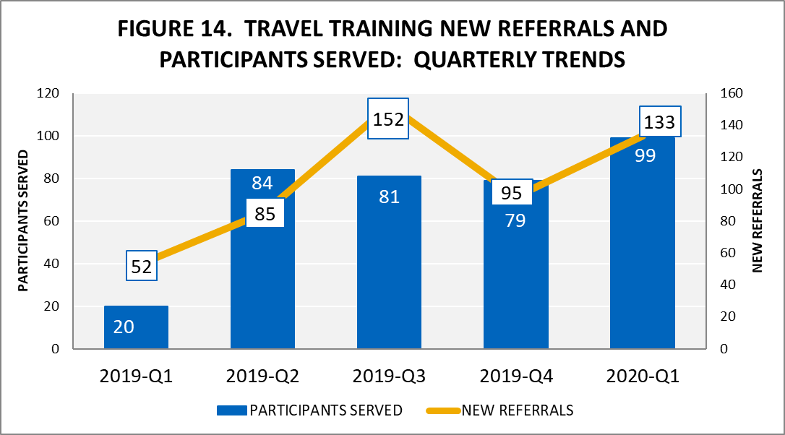
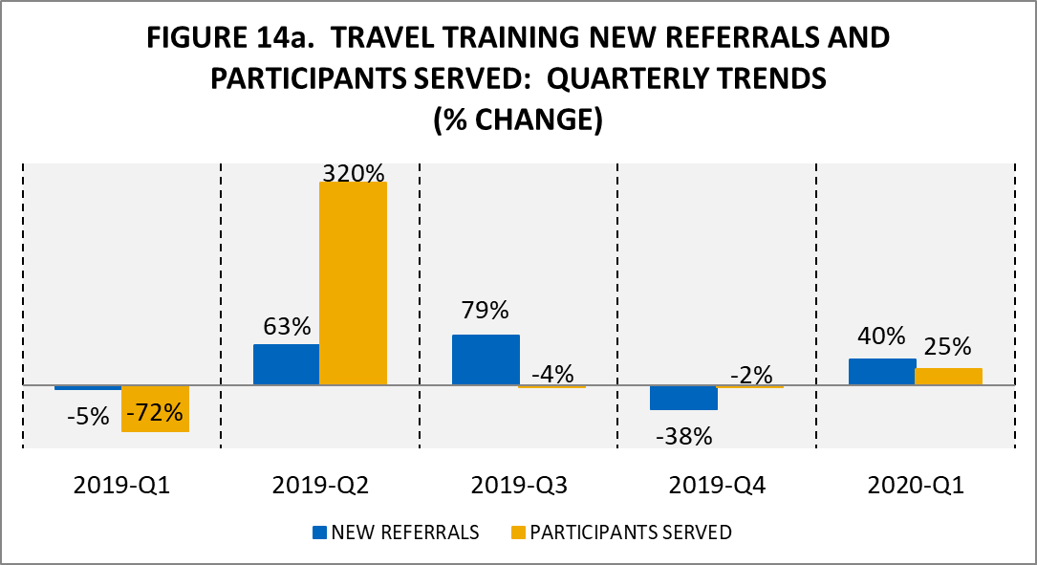

Annual Trends

Figure 15 reflects the number of referrals the Travel Training Program received and number of participants served year to date (YTD) as of the first quarter of 2020, and YTD for each of the previous four years. Through the first quarter of 2020, 133 customers signed up for Travel Training and 99 trainees were served.
Figure 15a reflects the percentage change in Travel Training referrals and participants served for the same period. Through the first quarter of 2020, there was 156% increase in customers who signed up for Travel Training verses YTD 2019, and there was a 395% change in the number of Trainees served verses. YTD 2019. This increase can be attributed to Mobility Outreach staff obtaining a large number of referrals for the Travel Training program in this quarter.
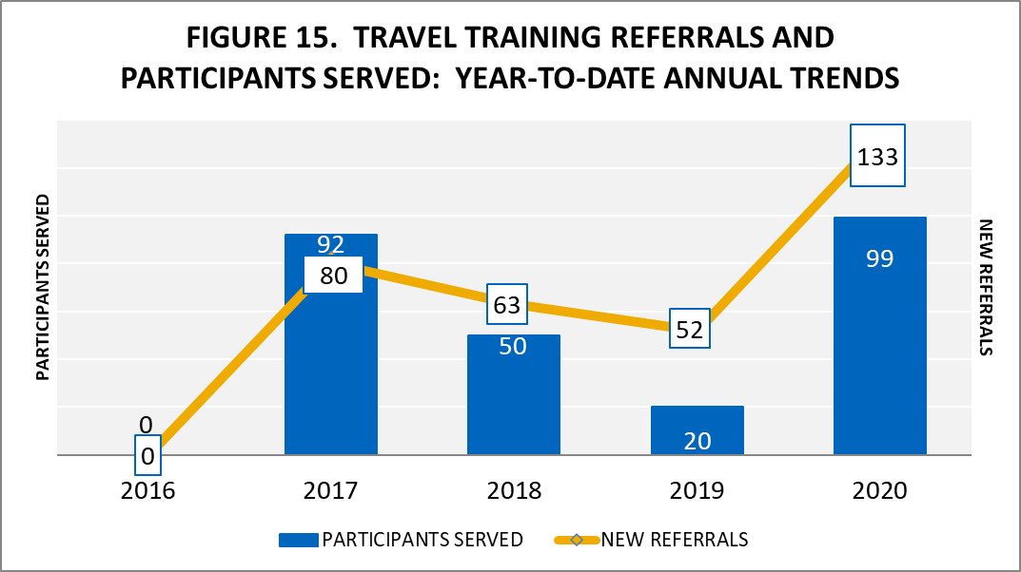
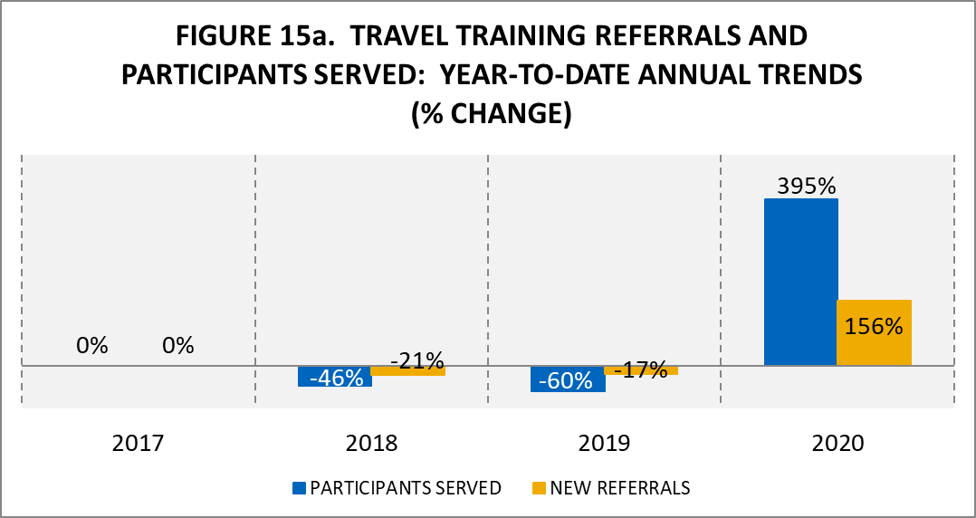

Group Transit Orientation Presentations & Community Outreach

Quarterly Trends

Figure 16 reflects the number of presentations provided and community outreach events attended by Mobility Management staff for each of the last five quarters. In the first quarter of 2020, 36 presentations were provided, and staff attended 13 outreach events, for a total of 49 events.
Figure 16a reflects the percentage change in presentations and outreach events for the same period. In the first quarter of 2020, there was a -42% decrease in number of presentations provided verses the fourth quarter of 2019, and a -72% decrease in the number of outreach events staff attended verses the fourth quarter of 2019. The decrease in the number of presentations and outreach events attended can be attributed to several different factors such as the decrease in Mobility Outreach staff available to provide presentations and attend outreach events, the decrease in the request for staff to attend outreach events and provide presentations during the winter and holiday months, and the number of events that were canceled in March due to COVID-19.
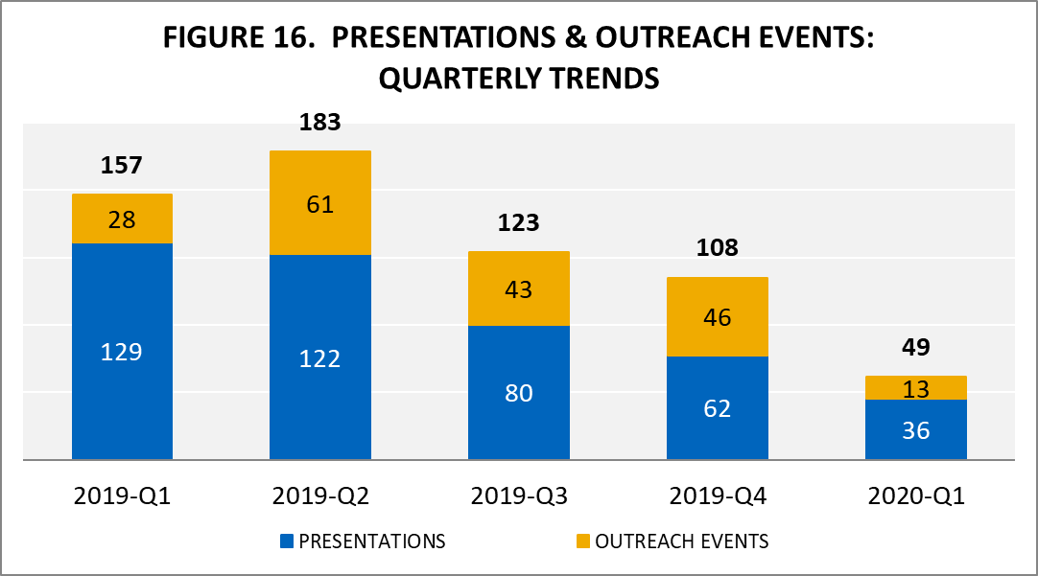
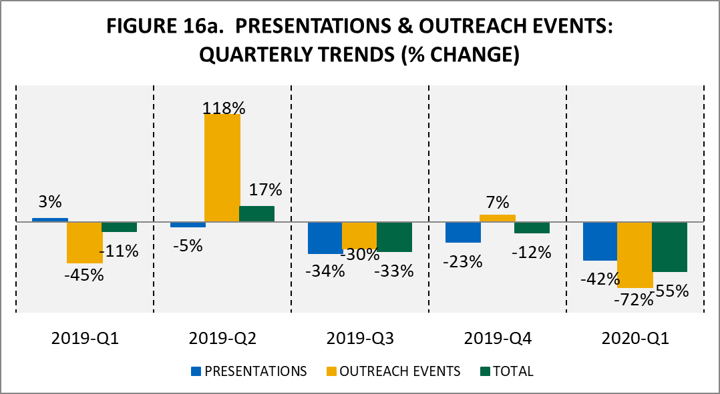

Annual Trends

Figure 17 reflects the total number of presentations and outreach events the Mobility Management team provided YTD as of the first quarter of 2020, and YTD for each of the previous 4 years.
Through the first quarter of 2020, 36 presentations were provided, and staff attended 13 outreach events, for a total of 49 events attended in the first quarter.
Figure 17a reflects the percent change in presentations and outreach events provided for the same period. Through the first quarter of 2020, there was a -72% decrease in presentations provided verses YTD 2019, and a -54% decrease in outreach events attended vs. YTD 2019. The decrease in the number of presentations and outreach events attended can be attributed to several different factors such as the decrease in Mobility Outreach staff available to provide presentations and attend outreach events, the decrease in the request for staff to attend outreach events and provide presentations during the winter and holiday months, and the number of events that were canceled in March due to COVID-19.
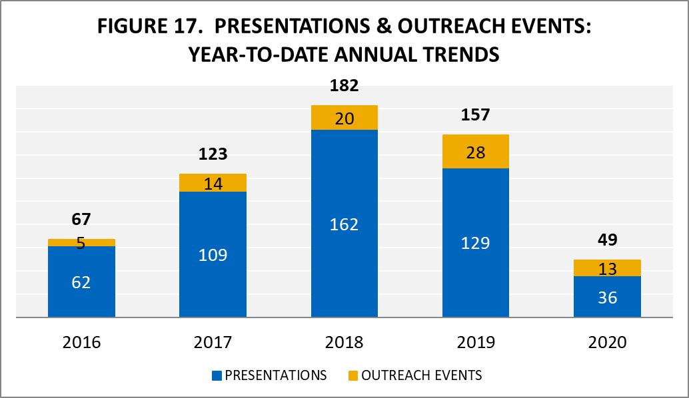
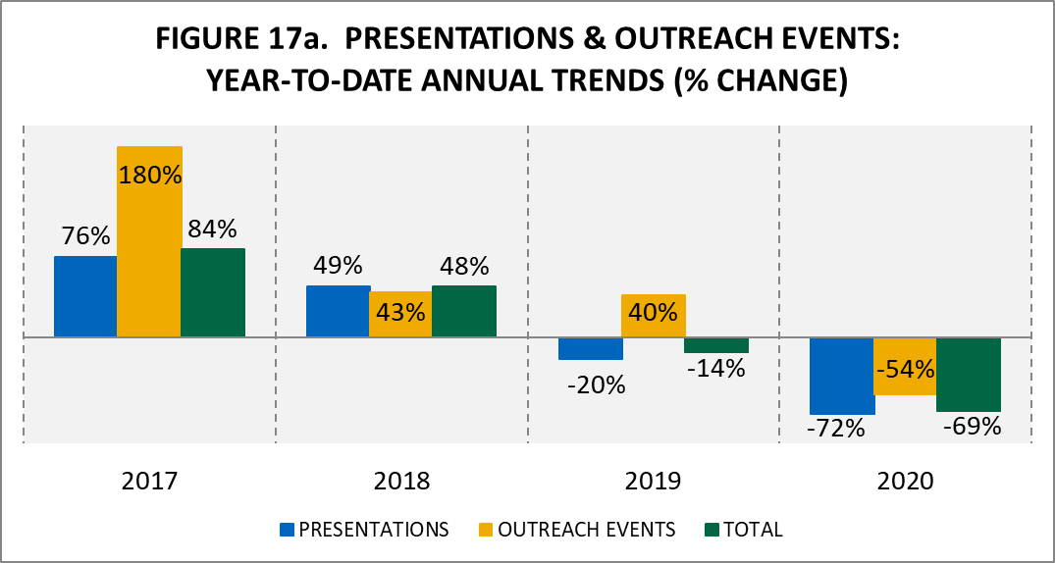

Community Participants Served

Quarterly Trends

Figure 18 reflects the number of presentation participants served and the number of outreach events the RTA participated in for each of the last five quarters. In the first quarter of 2020, 524 customers attended presentations, and 357 customers were served at outreach events.
Figure 18a reflects the percent change in customers served at presentations and outreach events during the same period. In the first quarter of 2020, there was a -49% decrease in customer attendance at presentations verses the fourth quarter of 2019, and a -87% decrease in customers served at outreach events verses the fourth quarter of 2019. These decreases can be attributed to a decrease in Mobility Outreach staff available to provide presentations and presentation and outreach events that had to be canceled due to COVID-19.
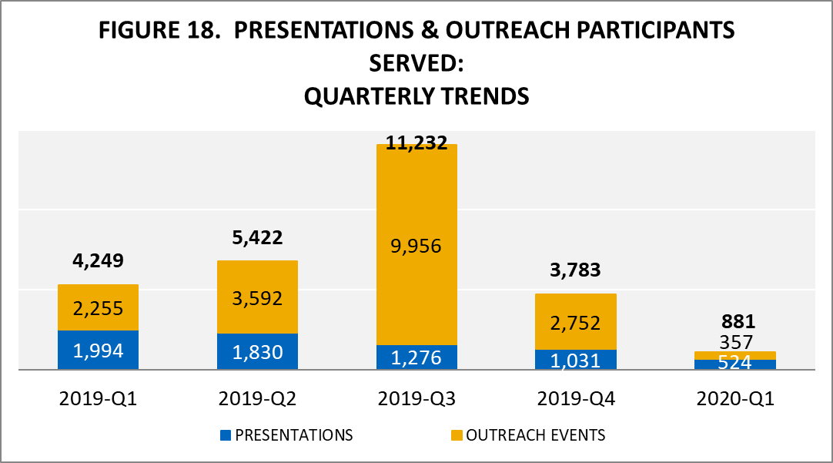
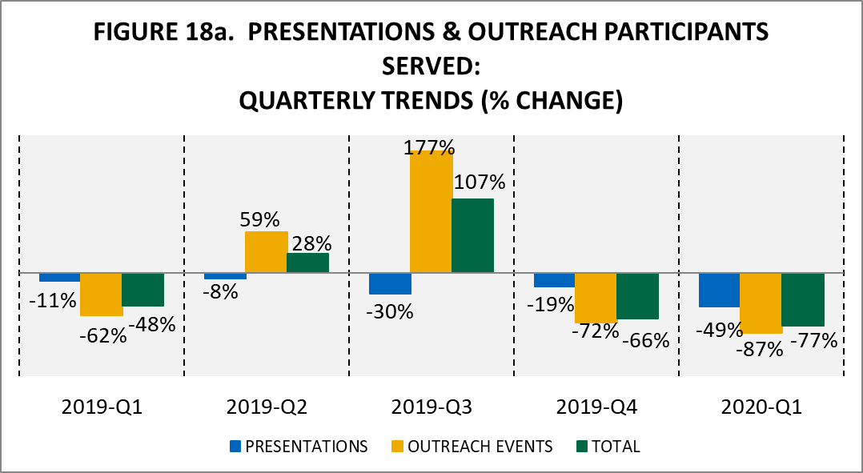
Annual Trends
Figure 19 reflects the total number of customers served at presentations and outreach events YTD as of the first quarter of 2020, and YTD for each of the previous 4 years. Through the first quarter of 2020, 524 customers were served at presentations, and 357 customers were served at outreach events, for a total of 881 total customers served.
Figure 19a reflects the percent change in customers served at presentations and outreach events. Through the first quarter of 2020, there was a -74% decrease in customers served at presentations verses YTD 2019, and a -84% decrease in customers served at outreach events vs. YTD 2019. These decreases can be attributed to a decrease in Mobility Outreach staff available to provide presentations and outreach events being cancelled due to COVID-19.
